Stealth ASD20/20BT New Style Pad Driver Removal
The following address the occasional problem with pad drivers that will not release when using the easy off feature.Notice below how the clip locks the lug on the pad driver, if this is too tight the pad driver will not release properly.
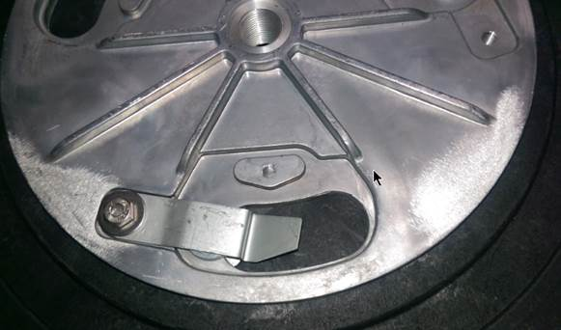
From the bottom side of the pad driver there are access holes for the end of the clip. It will be necessary to remove the batteries and place the machine on its side to more easily access the bottom of the pad driver.
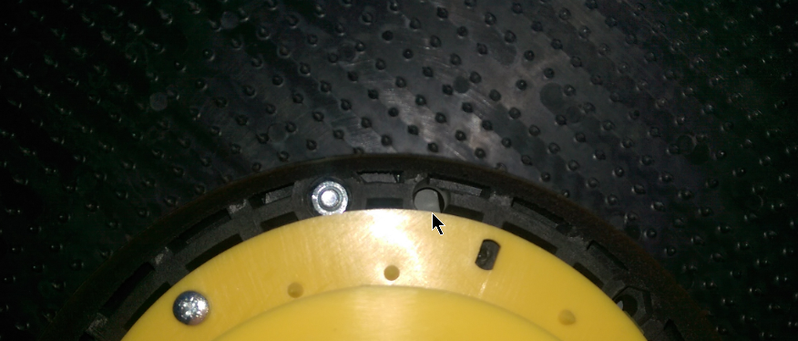
Inset a screwdriver/punch through the hole and force the clip up and it will release the pad driver.
